Day 1 - Kubernetes Introduction

* It is container orchestration tool. So, container orchestration mean, which is used to manage or to deal with your containers. In docker, we created containers.
* We use Docker to launch the container. Okay, you create a docker image out of an application. After creating the docker image in order to access your application. We containerized it. Okay? So we worked on one container. What in real time scenarios, you have multiple containers. You will be dealing with a lot of containers. So in order to manage those container.
* we go with a tool called Kubernetes
* This was developed by Google just to manage your containers. Okay without containers, You cannot work with Kubernetes. So Kubernetes require containerization technology to work on. So here we use Kubernetes to manage the container to monitor the container to take complete control of your containers Lifecycle, we will be using Kubernetes.
* The Kubernetes follows a master slave architecture. You have a master Node, and you have a slave node. We create cluster with Kubernetes. Cluster means you have multiple machine connected with one another.
* We will be creating cluster in eks. or if you're using azure, we have Aks, Kubernetes cluster a service provided by different cloud providers, or you can also create your cluster on premise.
* So Eks will help you to create the cluster, launch. The Kubernetes cluster in the Aws environment. You can go the manual way. So you create you click on, create cluster.

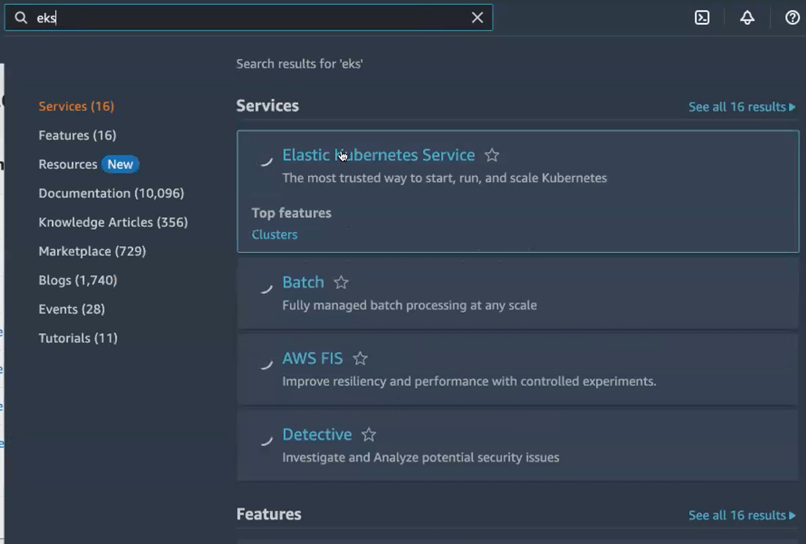

Its not free ..all are chargeble

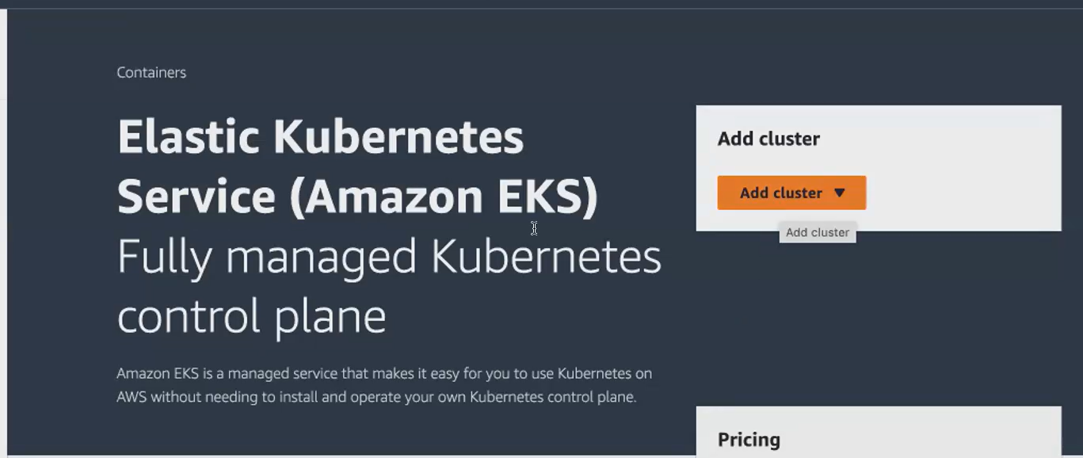

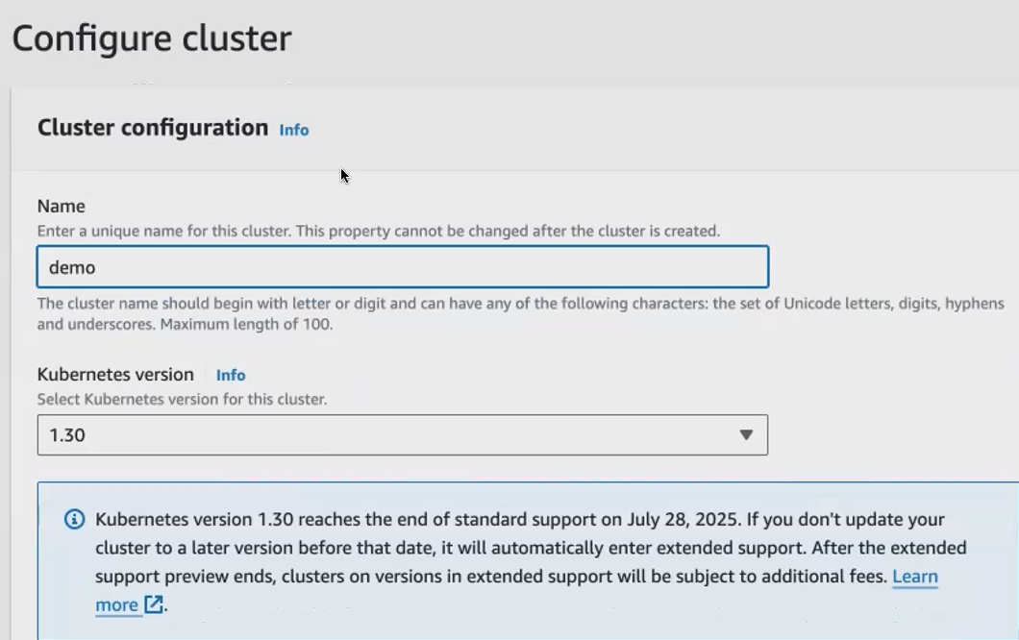

While add cluster , ask for **eks cluster role** .

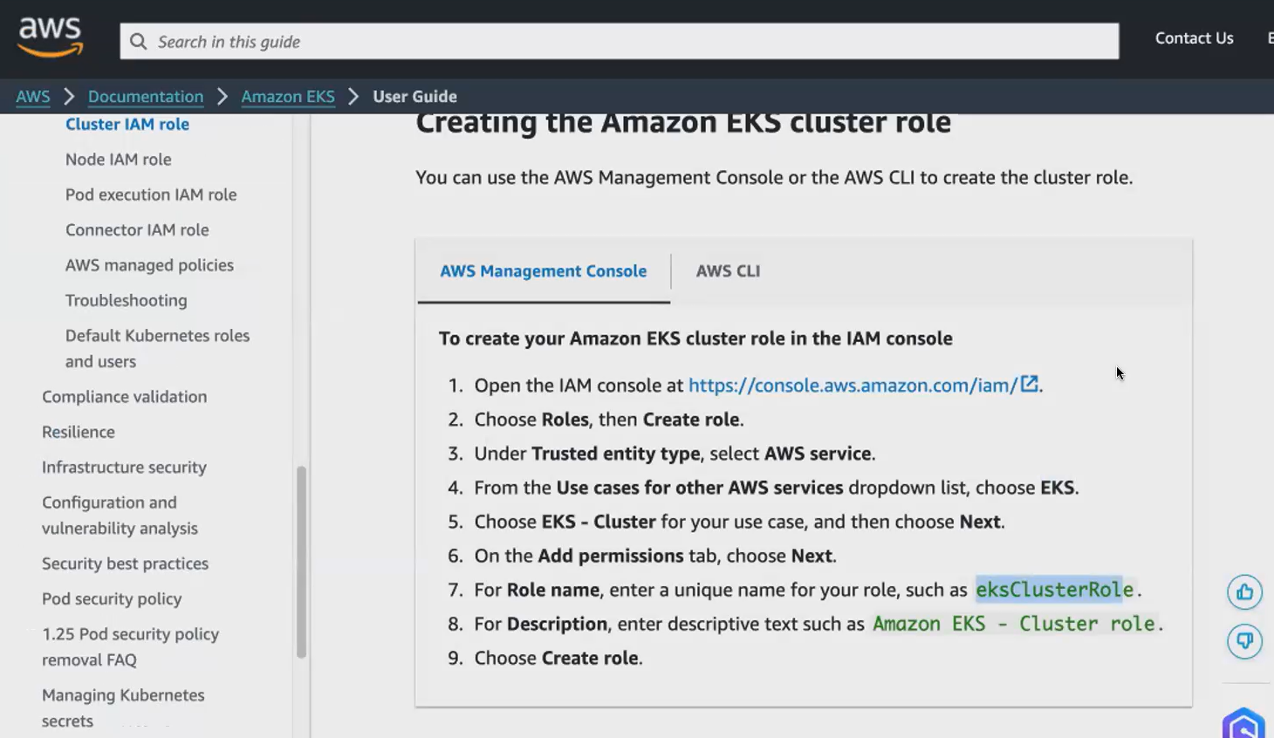

Scroll down

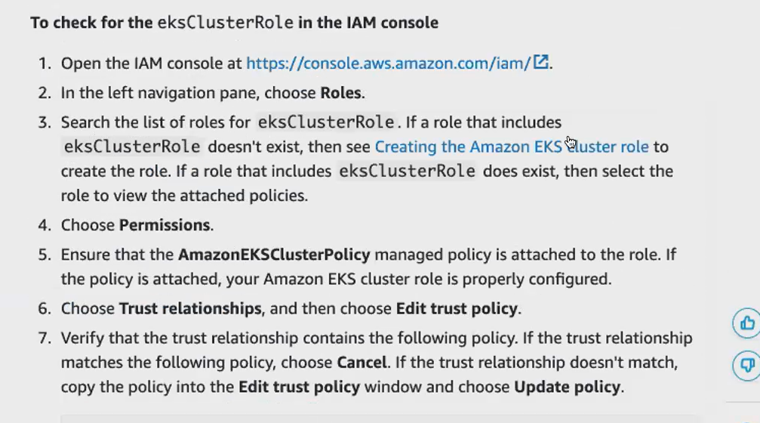

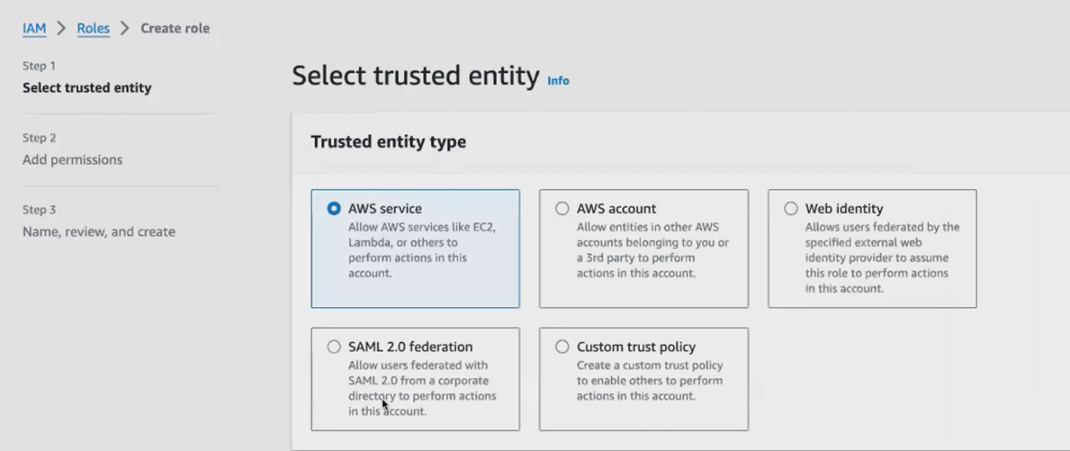

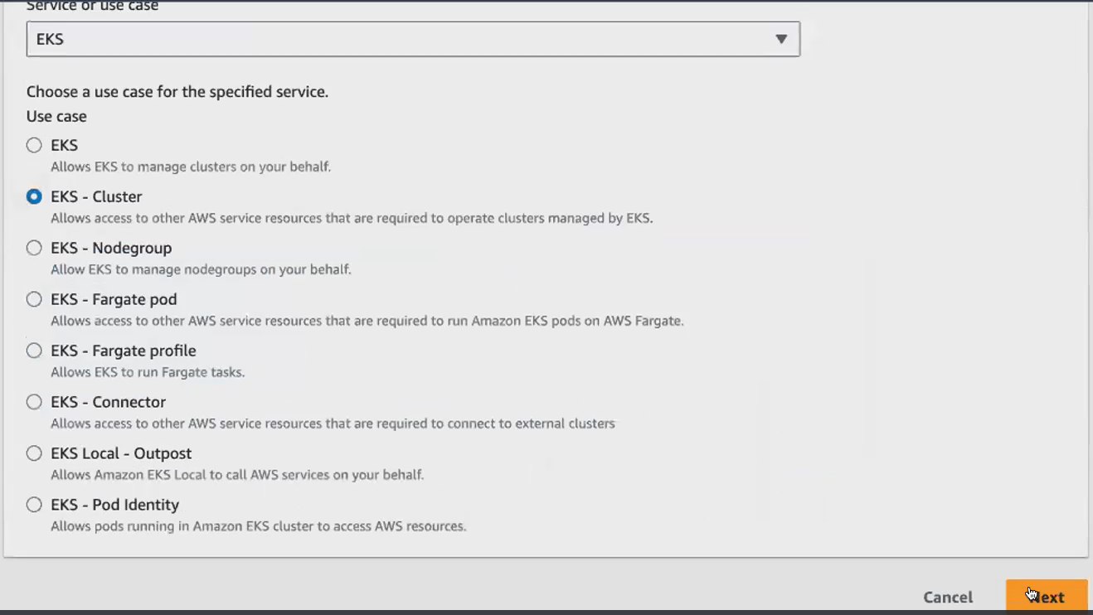

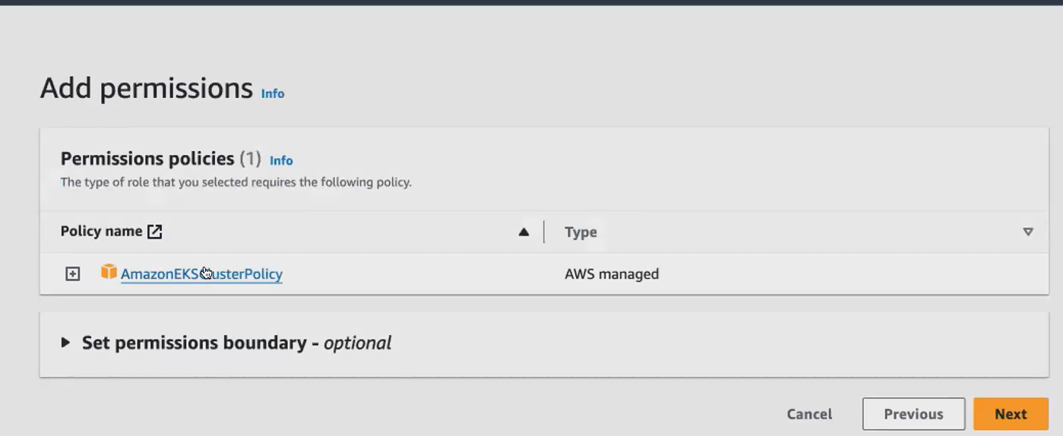

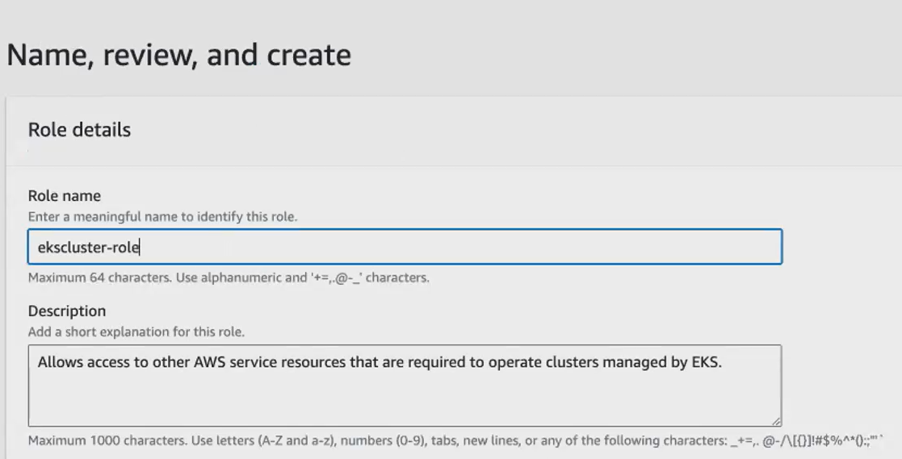

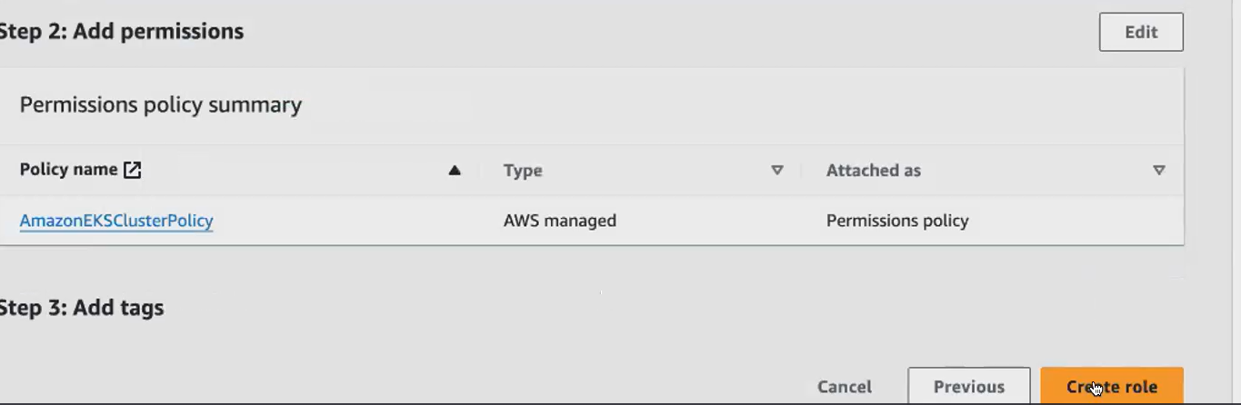

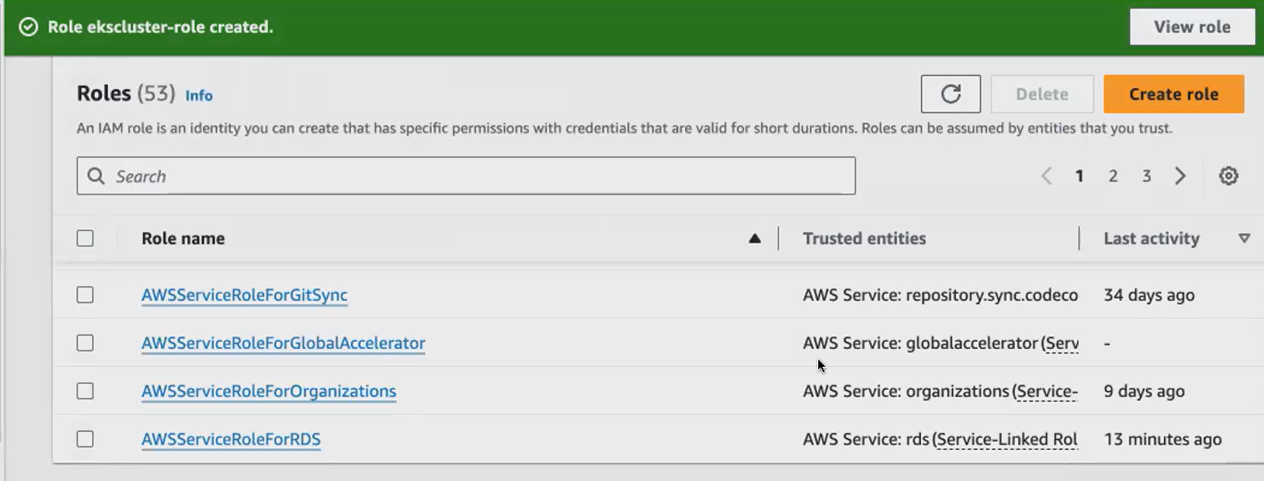

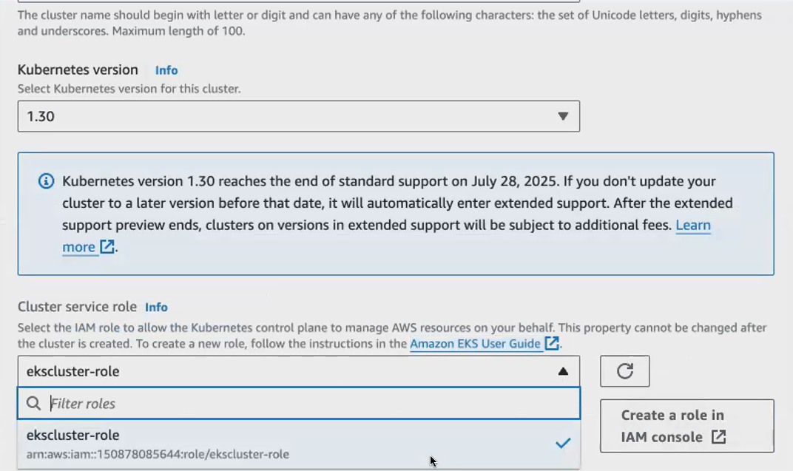

Remaining are all same in configure cluster. Click next

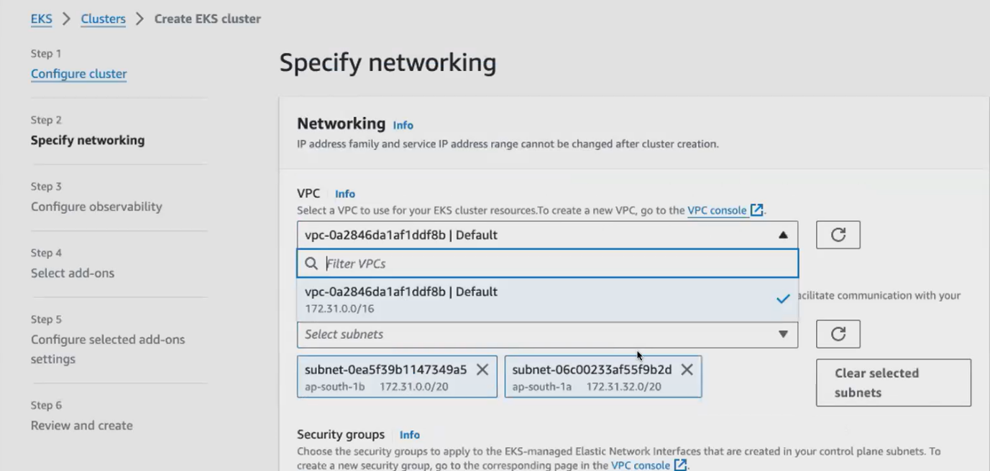

Security group is auto selected

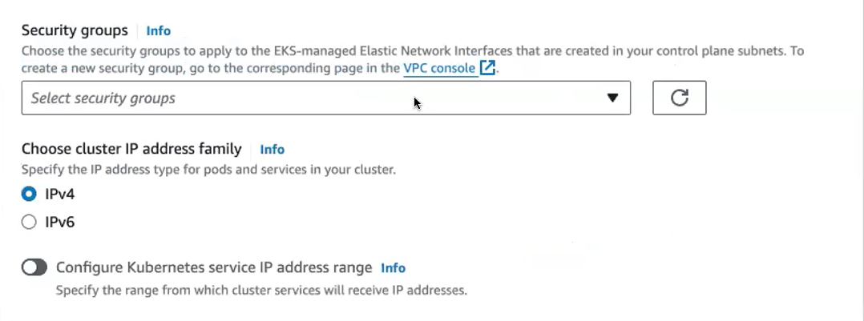

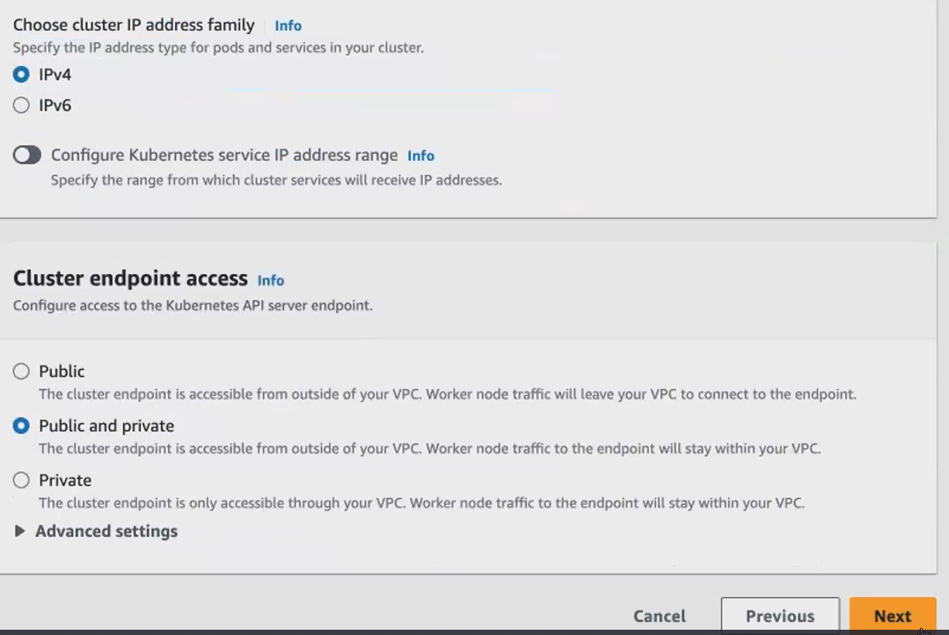

**I don't want to enable any observability, your metrics, your cluster details, your application that is running inside your cluster. Everything will be monitored.**

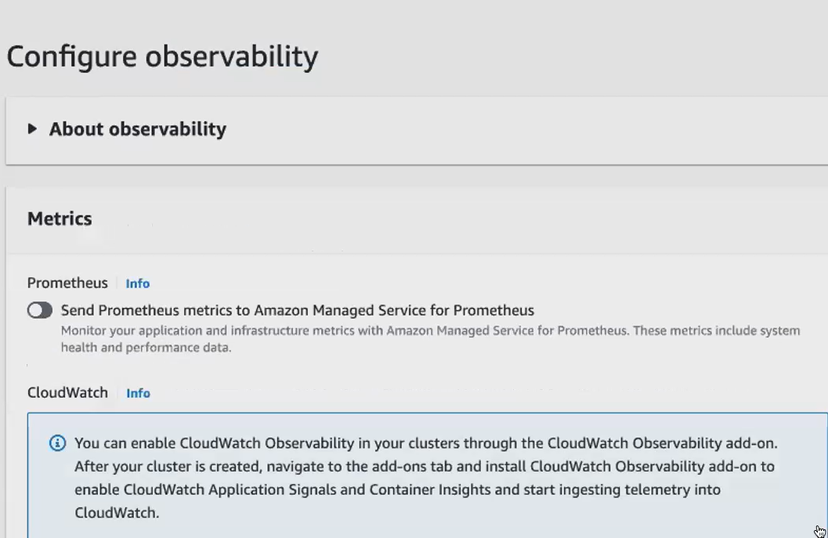

All are default add -ons .must be selected all

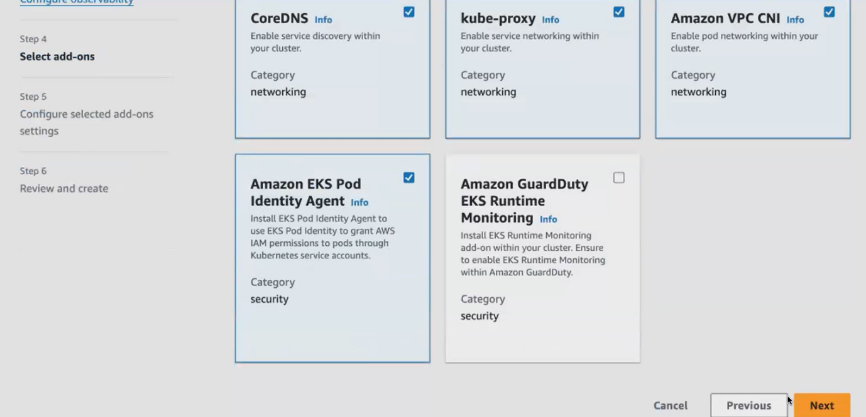

Already all selected

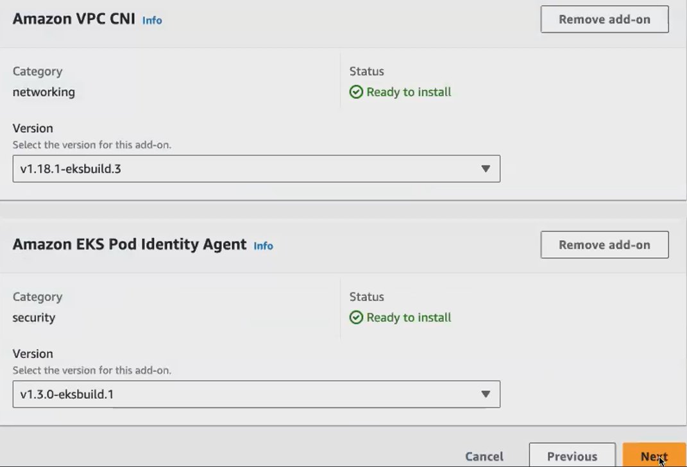

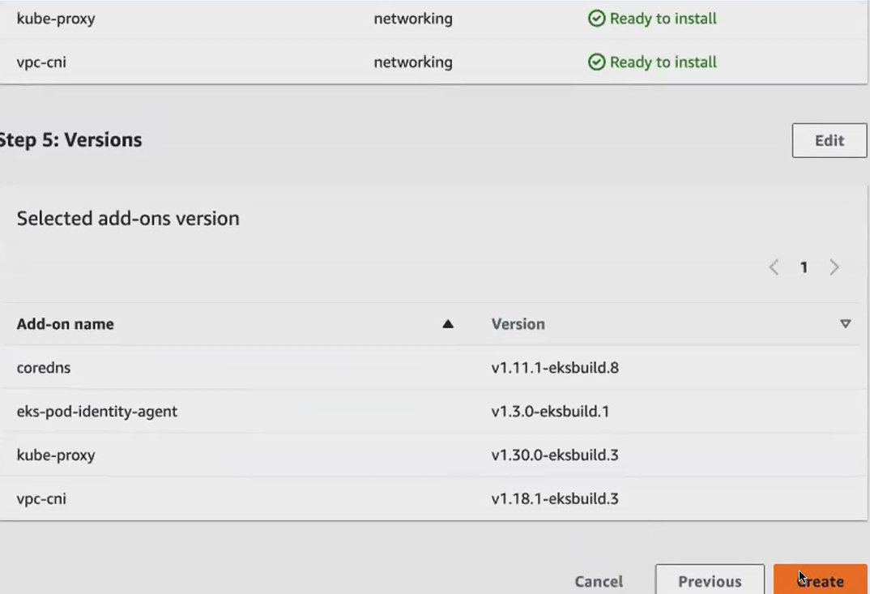

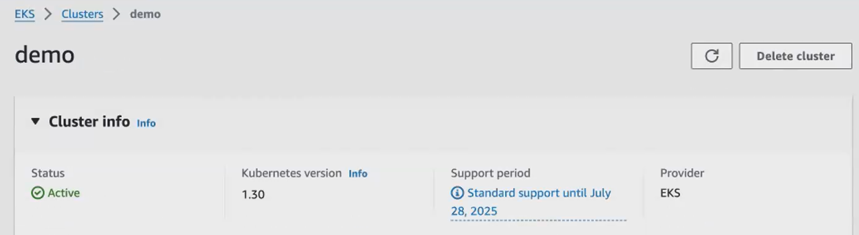

Launch an ec2 for cluster. Select ubuntu 🡪t2.micro

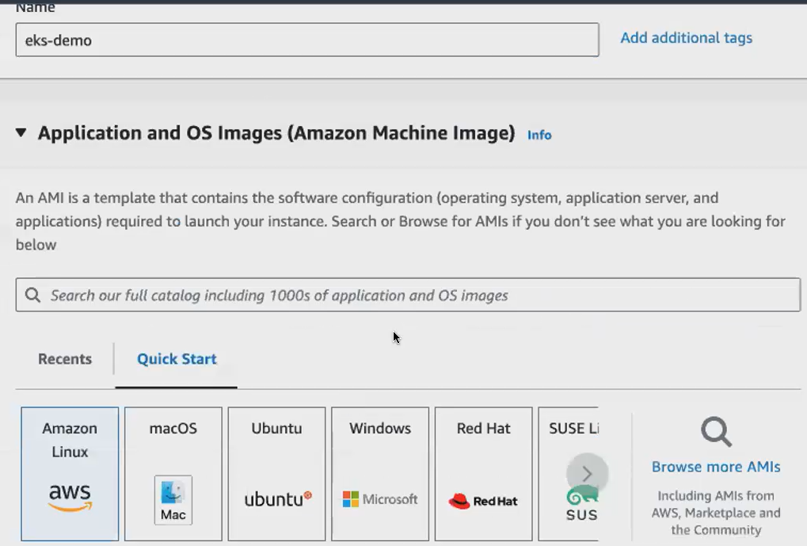

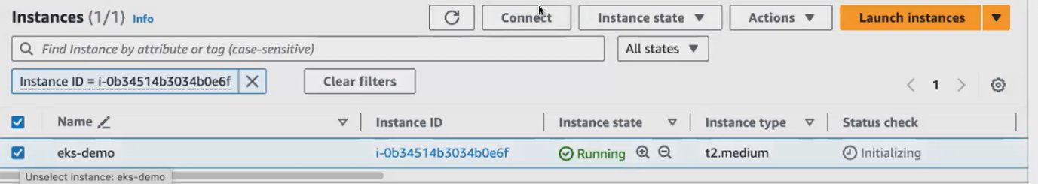

Connect an instance install awscli





How to generate access key and secret access key:

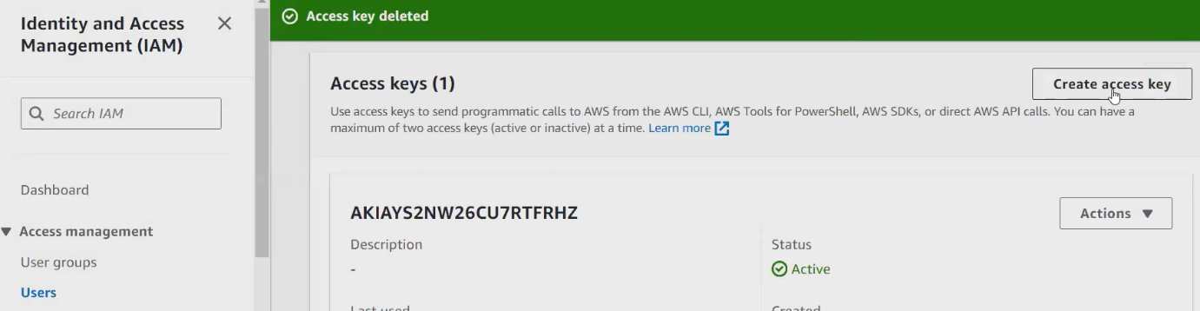

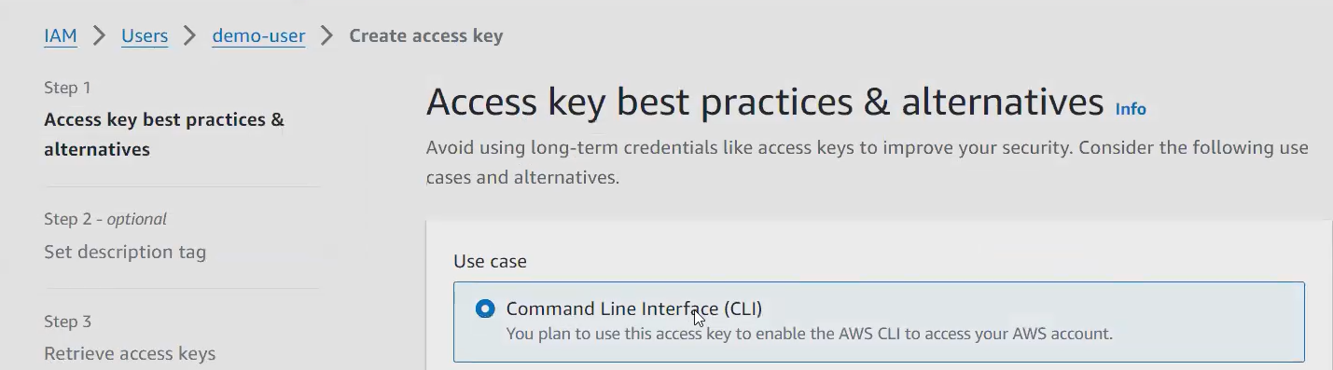

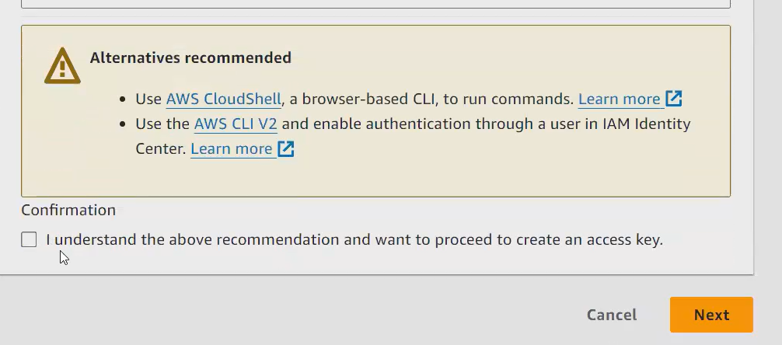

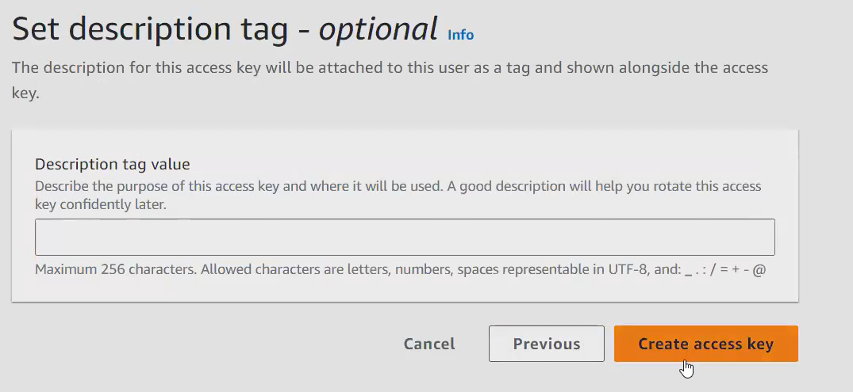

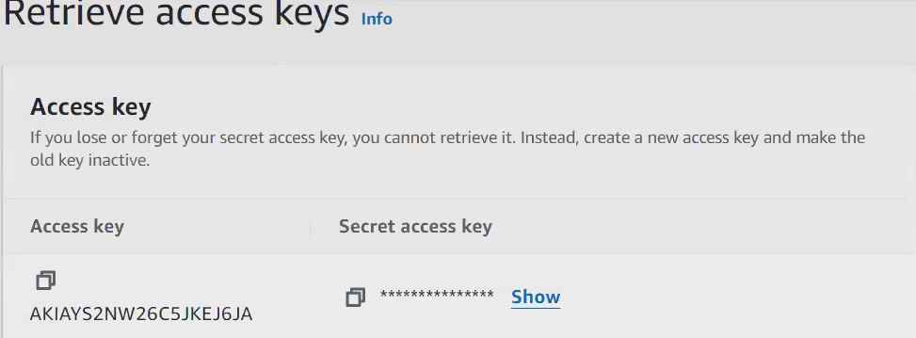

**How to install eksctl and kubectl:**

To communicate with your cluster. As I already told you we use kubeCtl, your cluster, you can create it in different way. You have different methods to launch your cluster. But to communicate with your cluster. We only use a tool called kubeCtl.

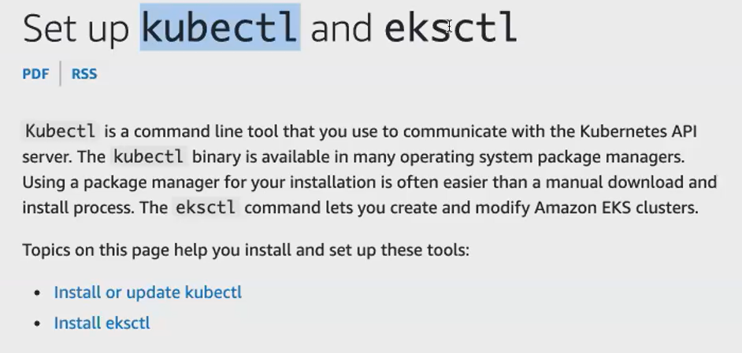

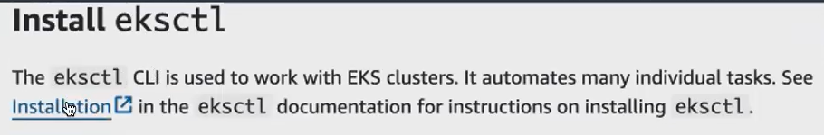

<https://eksctl.io/installation/> [ below cmd in this doc link]

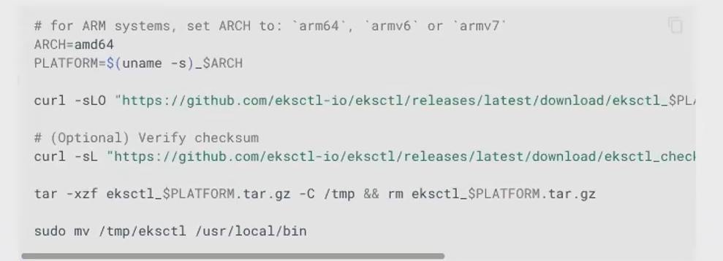

<https://docs.google.com/document/d/1w4DZAbVGEZLe4pnzGAzi-d3LcNh5wZtQ/edit?pli=1#heading=h.gjdgxs> [all commands in this doc]





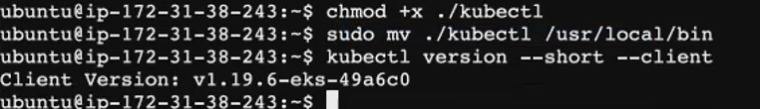

Create a cluster by using eksctl:

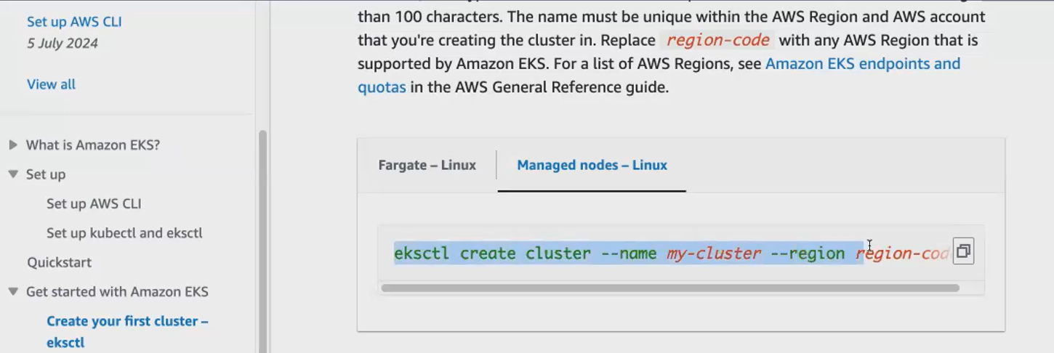



eksctl delete cluster --name demo-guvi --region ap-south-1

1. Name of cluster
2. Region
3. Node type
4. Min no of nodes -2 [always maintain 2]
5. Max no of nodes -10

<https://docs.google.com/document/d/1w4DZAbVGEZLe4pnzGAzi-d3LcNh5wZtQ/edit?pli=1#heading=h.gjdgxs> [ above all commands in this doc ]

cluster created

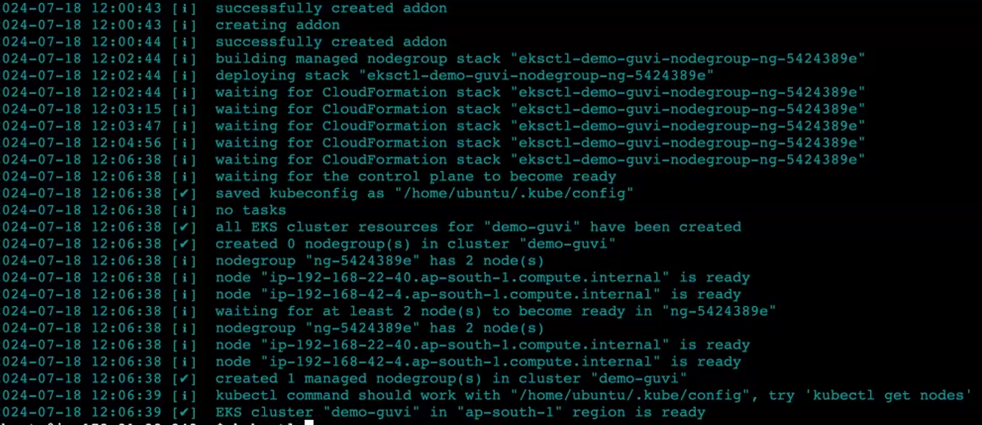

2 nodes created



* Ng is nothing but Node Group. Node group means so your cluster, what it will do to create a new group inside the Node group. It will play all your worker nodes. Okay, you have a node group.
* **worker Node one and Worker Node 2 worker nodes got created. It's nothing but your Ec. 2 only it acts as a slave machine of your Kubernetes. It is cluster.**
* **In the Kubernetes**

1. **master Node [ taken care by aws]**
2. **worker node [ we have to take care]**

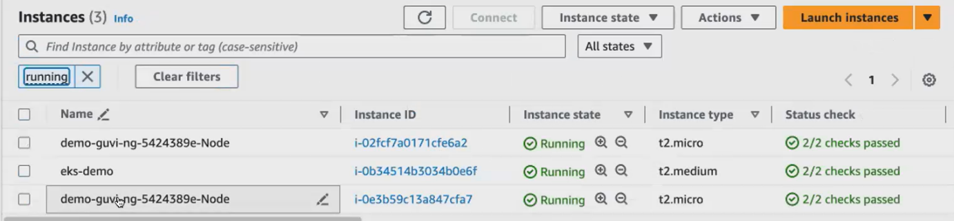

* coming to your Kubernetes cluster, we have an object called Pod, so we will be creating pod within your pod.
* We will be hosting **containers. We will be hosting our application containers, so you cannot directly launch your containers inside the Kubernetes cluster. Instead, you will create a** component called pod within your pod, we will be running the containers.
* So, if you see here, you have a node, which means you have a Kubernetes cluster inside the Kubernetes cluster. Now we have 2 worker nodes, so I assume that you have 2 worker nodes within your worker Node. You create multiple pods. Every pod. You are running your Kubernetes. You're running your docker container inside the pod.
* So you create a port and then you launch your container inside the pod, a pod can have one or more container. It is not necessary that your port can only host one container your pod can have one or more containers running inside the pod. Okay, so what we do, we will be launching this pod inside the pod. You launch your containers.

create your worker node:

you have created your cluster, so only your master Node will be created. So you have to launch your worker node. You have something called this Manage node group, you click on it, and you create your worker Node.

Worker node means you can have multiple worker notes. That is your slave machine for your Kubernetes cluster, and you will be launching it. It will create. You'll for this cluster. You have a master node, and you have your worker notes so you can create multiple worker nodes and attach it to your Kubernetes cluster. This is one way of configuring your Kubernetes cluster.

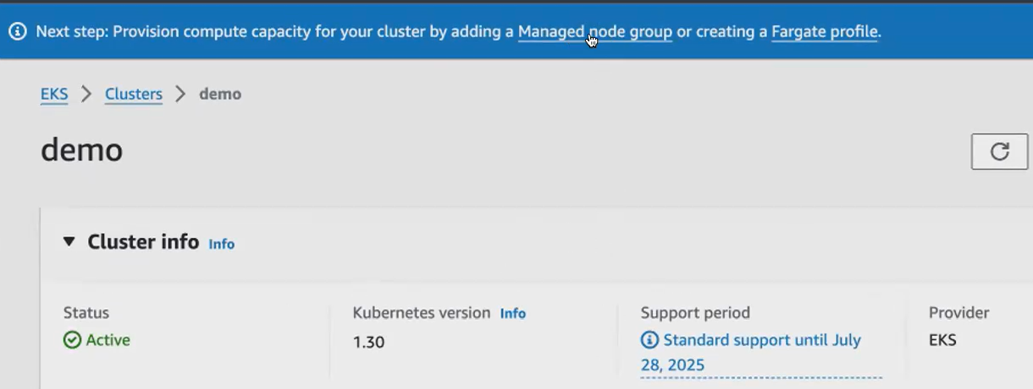

Pod :

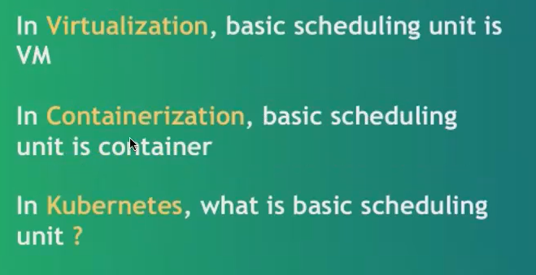

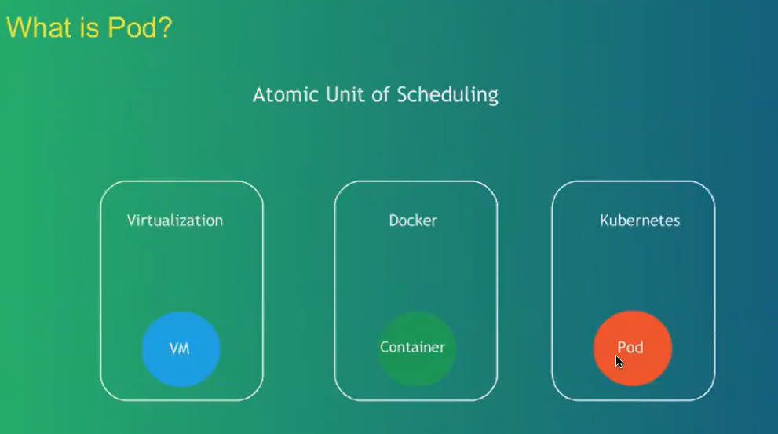

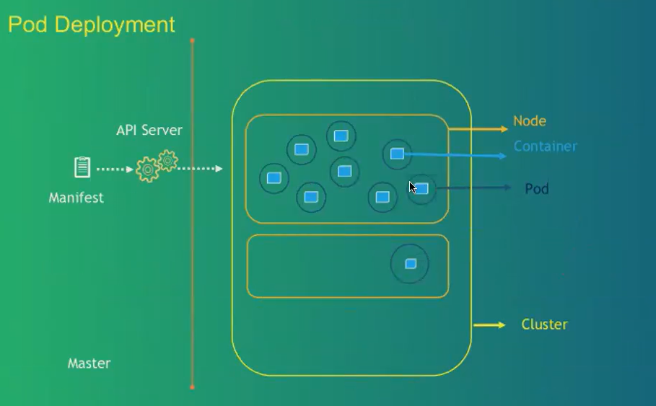

we will be creating a manifest file via that manifest file, your Kubernetes resources, or pod. Pod is one of your Kubernetes resource. Okay, can be created inside your cluster.

So, this is how your manifest file will look like it is. It is in the Yaml format. So, throughout your journey you will be writing this Yaml. You'll be writing lot of configuration files in the format**.**

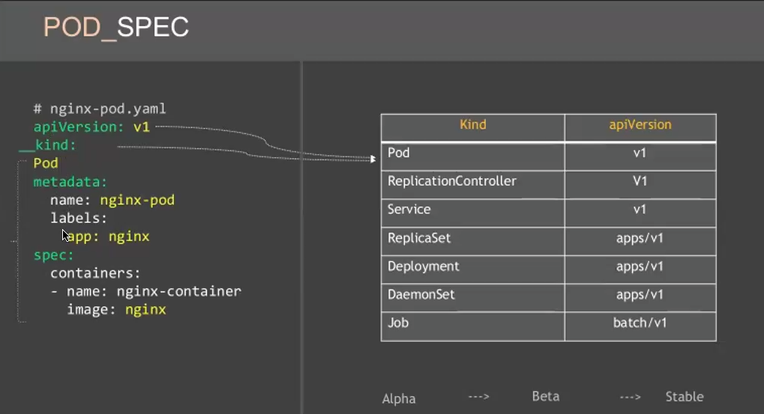

It will create a container, and this container will be launched inside your pod. A pod will be created inside the pod container will be created. A container will be launched with the image that you have specified.

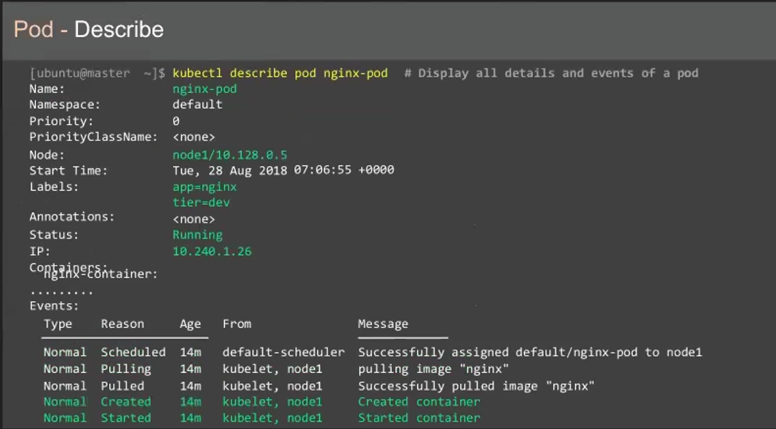

**Create a pod manifest file:**

For manifest file, So always your pod manifest file will have an extension of Yaml. We are using Yaml format to create that manifest file.

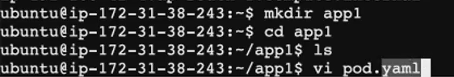

**Pod.yaml file:**

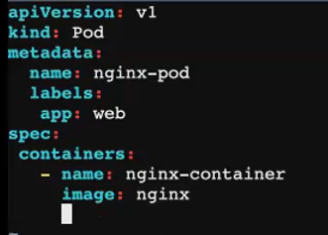

Using kubectl we can launch pod resources inside Kubernetes cluster. kubeCtl is going to communicate this to the cluster.

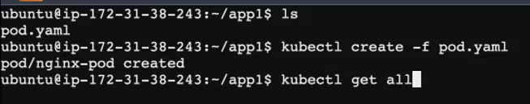

-f --- file name

Kubectl get all --- give all files inside the cluster

Kubectl get pod – shows pod creation

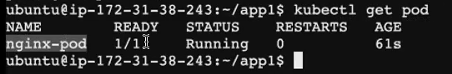

you get the complete detail of the pod, how the pod is being created. Everything, all the details. You get it in the Yaml format.



now we have created a pod which is running our container and inside the container, you have your application running inside it. So, in case if you want to expose your pod, if you want to access your pod outside the cluster. So now I have my Internet's application running. And I want to access my application through my browser.

since it's running inside the pod and your Kubernetes cluster is very secure. You cannot simply access the resources that is running inside your Kubernetes cluster. You have to create a file, you have to create a resource called service via service, you should be able to access the application that is running inside your pod.

In the real time we don't directly run the pod. We don't directly run the pod straightaway inside the Kubernetes cluster because pods are ephemeral in nature. your pods are ephemeral, which means it can be easily deleted.

**create a resource called deployment:**

what will happen if your pod gets deleted all of a sudden? Because now I have my application running in one of the pod. I have the application running only in this pod It's completely dependent on this pod. Something happens to this pod. My application will also be unavailable. In order to avoid that, what we do, we create another resource just to manage this pod. We **create a resource called deployment.**

So, you don't run your pod separately inside your cluster. Rather, you create your deployment. And inside the deployment you launch your pod and you run. You create your pod. Okay? So what we do now, we will go and create the deployment.

So deployment is like a super set to have a deployment inside the deployment to create your pod inside the pod You have your container. Okay? D**e**ployment is also a resource of your Kubernetes cluster.

Replica set takes care of your replication of your pod. So, you can maintain multiple pods, multiple similar pods with the help of replica set. So, your deployment will take care of the replica set and the pod.

your deployment will create multiple replicas of your pod, you will. You will be able to upgrade your application. If you want to upgrade the nigix application. Now you're using the version 1.5, and tomorrow you want to upgrade it. Then to a different version that is also possible with the help of deployment.

but with the pod you cannot do it. So, with the help of deployment, you can upgrade your application, and in case you don't want the current version, and you want to roll back to the previous version itself. You can also roll back your application to the previous version with the help of rollback command that we use with the deployment you can scale up and scale down based on the applications requirement, and you can also pause your application and assume your application.

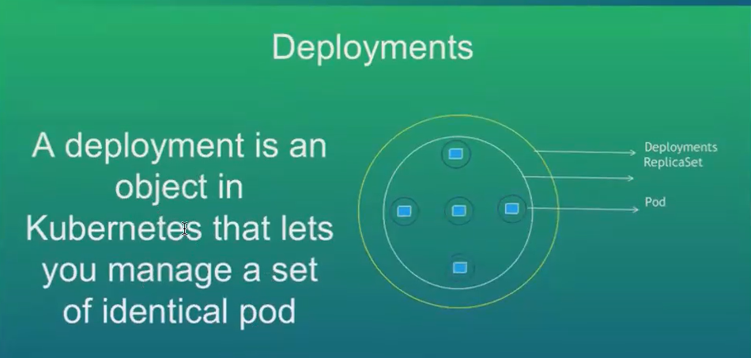

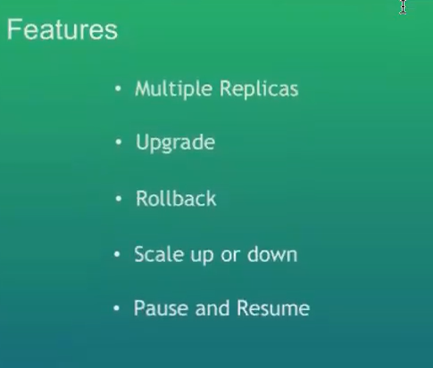

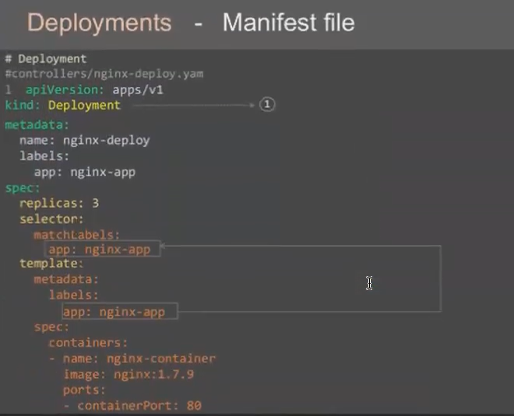

* You either call it as a manifest file configuration file or a yaml file to create your deployment. We call it as deployment manifest file. So, as I told you, any manifest file that you use inside your cluster will only have 4 components. That is your Api version, kind metadata and spec for deployment.
* Your Api version is going to be apps/V1/ You mentioned the kind, the type of the resource that you're creating. You're creating a deployment and you give name of your deployment. And how do you identify the deployment inside? The Kubernetes cluster with the help of labels.
* here only the only your spec will be different. So your podspec was completely different. So in the podspec what you had, you had only the container, because in your inside the pod you only have your container. But now, inside your deployment, you have a pod within the pod. You have your container running.
* while creating your pod , same template, same things that you mentioned inside your template? So under your specification of your deployment. You mentioned the replicas selector and template under your template parameter. You mentioned all your port details, you give all your port details. You mentioned the label of your pod.

Deployment.yaml file :



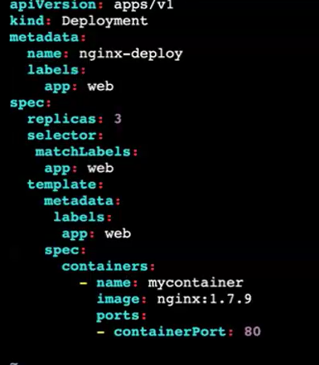



**Pod created via deployment:**

**We gave 3 replicas so 3 pod created**

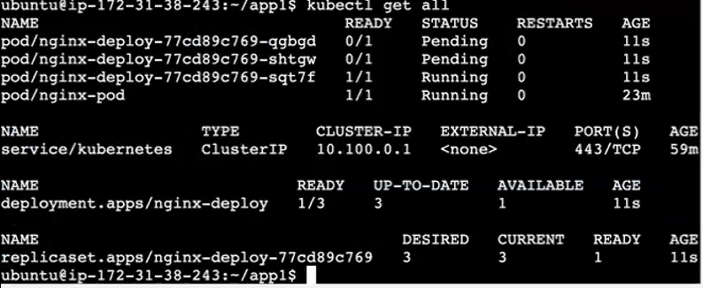

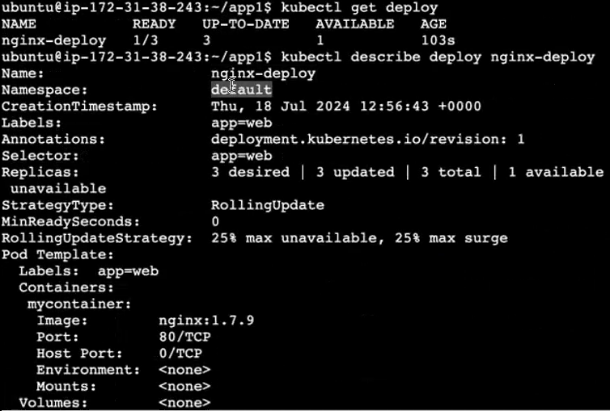

<https://docs.google.com/document/d/1w4DZAbVGEZLe4pnzGAzi-d3LcNh5wZtQ/edit#heading=h.gjdgxs>

[pod creation document]

Delete the cluster immediately:

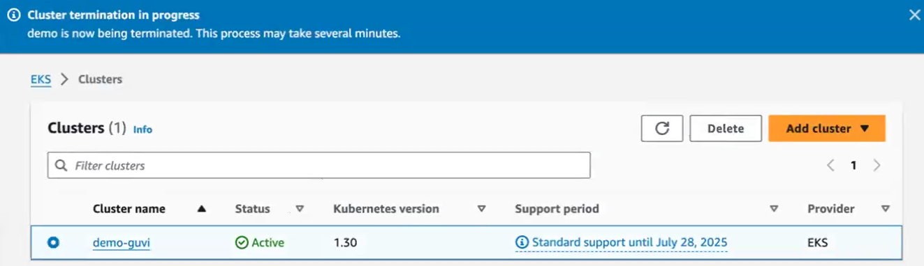



eksctl delete cluster --name demo-guvi --region ap-south-1